The Statistical Approach

14.22 - Estimating parameters algorithmically
So far, we have used our intuition to manually set parameters that provide a close fit between our model's predictions and actual outcomes. Now, halfway into chapter 14, it is time for us to start automatically (i.e., algorithmically) estimating these optimal parameters. However, once again, we will embark on a slightly longer route before arriving at the general framework of machine learning using a method that applies to virtually all optimization problems.

14.23 - Closed Form versus Iterative Methods
In machine learning, we typically iteratively improve our model's parameters based on an error we compute between our predictions and the actual outcomes. During each iteration, we carefully update the parameters by moving a fraction in the direction of where we predict they will yield better predictions. Hopefully, we will settle at some point at a set of optimal parameters. If we are fortunate, these will be the best parameters possible. These parameters are optimal in some region of the parameter space we explored. Gradient descent (GD) is the method of choice for many machine learning algorithms to systemically traverse the parameter space in pursuit of these optimal values. And we will discuss GD in detail later in this chapter. Whereas this chapter can be the backbone of this course, gradient descent is the backbone of this chapter. It provides a very elegant approach and geometric intuition on how to think about and train highly complex machine learning models.
However, two methods allow us to compute optimal global parameters. In addition, it does not need us to iterate and search the parameter space carefully. Instead, they will yield the optimal parameters from a single pass over the training data. They are examples of closed-form solutions, which are deterministic and derived from first principles to always produce the most optimal solution under specific conditions. Mathematically, both methods are pretty much equivalent, but their implementation may, at first, look very different. And one of them is rooted in the field of statistics, the other a product of algebra. Before we describe them, we should answer why we don't always use these methods. Why bother with a slow, non-deterministic algorithm when you can bet on a horse guaranteed to win? Not all races are equal. Specifically, the statistical and algebraic methods won't be available for more complicated, non-linear machine learning models. The truth is, the reason they work so well for linear models is that linear models, per definition, only have one minimum - one set of optimal parameters. We need a different approach when that linearity is no longer a valid assumption. Specifically, we need an iterative method like gradient descent, allowing us to search for and find a set of parameters that yield predictions worth making. To fully appreciate this, it helps to visualize these parameter spaces and outline how we define and quantify a minimum in them. This will prepare us better for our discussion on gradient descent. But we will need to first introduce two metrics commonly used in machine learning to describe and measure model error and performance.

14.23 - Error
You may feel we already went through the steps necessary to compute model performance. Did we not just define the r-squared metric? Yes, in the previous chapter, we computed three related measures that allowed us to quantify our model's performance. We demonstrated that the Sum of Squares Total (SST), Regression (SSR), and Error (SSE) could tell us how much of the variance our model can explain in the variance observed in the output we are trying to predict. We would like to acknowledge that introducing two additional metrics to capture a model's performance can be slightly confusing initially. But stick with us. Hopefully, it will become clear soon enough.

(14.9)
Equation 14.9 - We define error associated with a data point i as the difference between the predicted and actual outcomes.

The first metric is simply called error and is not specific to any method described in this chapter, nor is it specific to linear regression. Error is the difference between our model's predictions and some objective ground truth, see Equation 14.9. If our model predicts you will have 5K in medical expenses, yet it is $6k, the error is -$1000. Notice that it matters what we subtract from what. If our model predicted $6k, yet the actual outcome was $5k, the error would have been +$1000. We must keep track of the sign and keep track of it correctly because updating our parameters will depend on it. If we consistently overshoot the actual medical expenses, we want to consider decreasing the slope or offset of my model and vice versa.

14.24 - Turning Error into Loss
The second metric is loss, which captures how much variance the model (still) hasn't accounted for. Minimizing overall loss is the objective during optimization or learning. But why do we need a new measure when we already have the error? For reasons detailed above, the error metric is a bit ambiguous. We have already seen that our error can be both positive and negative. How should we interpret these values in terms of performance? Is an error of -1 more than an error of 1? In other cases, we have categorical outcomes, like in a binary classification problem. If the labels in our data are defined as 0 and 1 (without any mathematical relevance), what does the error mean in that case? And since the error will always be -1, 0 or 1, are these values even useful as measures of model performance to begin with? This is where loss comes in. Unlike error, the way we compute loss is specific to the type of outputs our model generates. We rely on specific statistical distributions for binary and multiclass classification problems to convert error into the loss we need to optimize our models, which we will discuss in detail in the next chapter.

(14.10)
Equation 14.10 - The Sum of Squares Error (SSE), defined as the squared difference between model prediction and model outcome summed across n data points.

For linear regression, however, we have already seen the very equation that computes loss from error before. More specifically, it is the sum of squares error (SSE). We haven't used the SSE before, relying on the ratio between SST and SSR to give us the r-squared value instead. But by plotting it once more below, we can see how it fits into our current objective. Notice how that definition consists of three steps. First, we take the difference between our model's prediction and the actual outcome. If that looks familiar, it should because that is the error we already defined above. After that, we square the error value, which removes the sign. For a good reason, because for loss, we are not interested in which way we got it wrong (over or underestimation), but rather the extent to which we got it wrong.

(14.11)
Equation 14.11 - We define loss as the average squared difference between model prediction and model outcome across some subset of data points n.

The only thing still left up to us to decide is which errors are summed together. One way is to average the loss across all training data before updating our parameters. Alternatively, we can compute error and loss for each data point, updating the parameters every time we consider a new training data point. And then there is some middle ground between these two extremes. Why we would choose one extreme over another or opt to stay somewhere in the middle depends on assumptions we make about our data and model and is something we will discuss in detail later in the chapter when we discuss different training regimes.

14.25 - Loss Landscapes
Now we have defined loss, we can visualize it as a function of a range of parameters. We generated a small synthetic data set that is entirely linear, except for a bit of noise added to the outcome y. For its parameters, we set the slope a and the offset b to 1, giving us a straightforward linear model of y = ax + b, see Figure 14.17a. With only a small amount of added noise, it is safe to say that the lowest error is found at a=1 and b=1. But what about all other possible combinations of a and b? How does the landscape of loss vary as a function of varying values of and b? We can plot the loss as a 3D mesh surface, where the x and y axis are ranges of different values for a and b, respectively, with the z-axis representing the loss of the model given a particular pair of (a,b) parameters. Notice that when we do, the resulting loss landscape (shown in Figure 14.17b) for our strictly linear dataset has a single optimal lowest point of a loss close to 0. Given that that point represents the parameters used to generate the synthetic data, it is not surprising that it is associated with the lowest theoretical loss we can achieve using our linear regression model. Move away in any direction from this point (by increasing or decreasing one or more of the parameters, and the error you observe between actual outcomes and your model's prediction will always be higher. We call this a convex space of solutions: a single valley with the optimal parameters at its lowest point. Keep in mind that this convexity is a property of the machine learning model, not the data. The data can be highly non-linear, and a machine learning model that captures such non-linearity might find a very different global minimum.

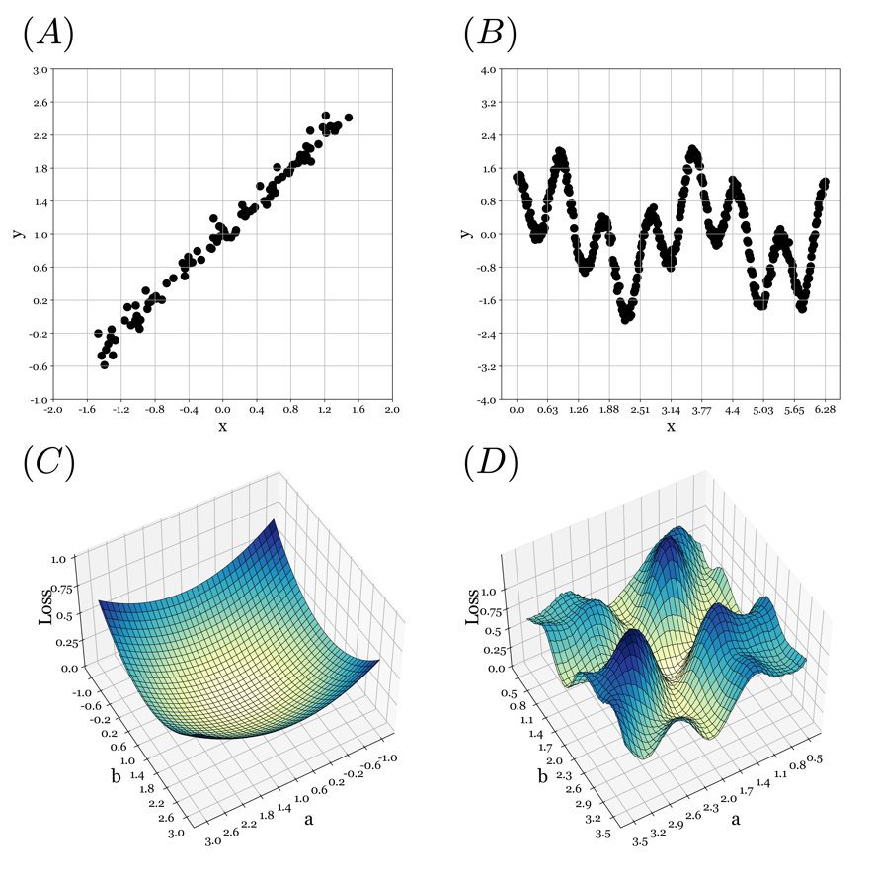
Figure 14.17 - Synthetically created data sets (A) and (C) and their associated loss landscapes (B) and (D). The synthetic data in (A) is linear: y = ax + b. As a result, the associated loss landscape for parameters a and b is convex, with a single global optimal set of parameters (a,b) that yield the best theoretically possible performance. The data in (B) was created by adding a sinusoid with frequency a to a sinusoid with frequency b. This yields a highly non-convex loss landscape, shown in (D).

What if instead the data shows a non-linear relationship between inputs and outputs? Figure 14.17c plots a different synthetic dataset which we made highly non-linear by design. When we plot the corresponding loss landscape for a range of parameter combinations (a,b), we can see multiple local neighborhoods where the parameters yield some optimal solution. This is true from a local perspective as all around such minima; the loss is higher. That doesn't mean that some other, more distant combination of parameters yields an even lower loss. If we were to try and fit a linear model to this data, we would not do well. The data in Fig 14.15c can't be described as a straight line, no matter how much we try and squint. It might fit some subset of the data, but it will also be at the expense of some other data. Like a USB cable straight from Dante's inferno, no matter which way you rotate it, it never seems to be aligned with the port you want it to connect with.

14.26 - Statistical estimates for our parameters a and b
Despite their limited use in machine learning, the statistical and algebraic methods still offer crucial insights into how to compute, estimate and optimize models to fit data. We will begin with the more familiar and intuitive method of the two, which you may have already come across in a statistics course where it is simply known as linear regression (with regression used as a verb, as in 'to regress'). It explicitly uses estimates of the mean, variance, and covariance of an input variable x and an output variable y to compute the slope and intercept we need as parameters for our model. If we have theoretical reasons to believe our model is indeed linear, we can use either the statistical or algebraic approach to find the optimal parameters.

 |  |  |  |  | 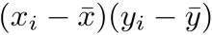
 | 52 | 9.75 | 204.49 | 9.79 | 44.74
 | 59 | 12.62 | 453.69 | 36.03 | 127.85
 | 32 | 4.65 | 32.49 | 4.23 | 11.73
 | 18 | 2.20 | 388.09 | 19.50 | 87.00
 | 54 | 11.51 | 265.69 | 23.94 | 79.75
 | 50 | 9.55 | 151.29 | 8.58 | 36.03
 | 34 | 5.12 | 13.69 | 2.24 | 5.53
 | 52 | 11.49 | 204.49 | 23.70 | 69.62
 | 18 | 1.62 | 388.09 | 24.98 | 98.46
 | 58 | 12.23 | 412.09 | 31.49 | 113.92
 | 19 | 1.74 | 349.69 | 23.84 | 91.31
 | 38 | 5.40 | 0.09 | 1.49 | -0.37
 | 45 | 7.45 | 53.29 | 0.68 | 6.03
 | 18 | 1.14 | 388.09 | 30.06 | 108.01
 | 28 | 3.17 | 94.09 | 11.89 | 33.45
 | 25 | 4.50 | 161.29 | 4.47 | 26.86
 | 52 | 12.59 | 204.49 | 35.67 | 85.41
 | 33 | 5.38 | 22.09 | 1.55 | 5.85
 | 25 | 2.72 | 161.29 | 15.20 | 49.51
 | 44 | 7.73 | 39.69 | 1.23 | 6.97
 |  |  | 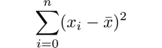 | 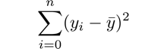 | 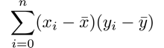
 | 37.70 | 6.62 | 3988.20 | 310.55 | 1087.65
 | Table 14.1 - Steps in computing the best fitting parameters using the statistical approach to linear regression.

More specifically, means, variances, and covariances are all used to weigh the contribution of each data point to the overall estimate of slope and intercept based on how statistically probable that data point is. Therefore, it is useful to think that at its core, linear regression aims at answering the following statistical question: what values of a (the slope) and b (the intercept) would have been the most likely to have generated the data we observed? Answering that question relies on metrics we have already defined, which can be found in Table 14.1. The table lists the 20 data points in our small, subsampled data set related to medical expenses and age (Figure 14.9), with one column added for each subsequent value we need to compute from the original (x,y) data. These are aggregated across all data points and used by Equations 14.12 and 14.13 to compute the best slope a and intercept b. We show the resulting fit in Figure 14.16. We can compare this fit to our best efforts in the previous section to generate parameters manually. It appears our guesstimated parameters were not too far from the theoretical optimal values given by the statistical approach outlined in this section.

(14.12)
(14.13)
Equations 14.12-13 - Slope a is the ratio between the covariance between x and y and the variance in x. We compute intercept b from the means of x and y and newly found parameter a.

14.27 - Beyond a single input variable
The statistical approach is easy to compute and understand when considering only a single input variable's effect on a single output variable. It seems unlikely we would ever build models this succinct. The math behind the method doesn't change by adding more input variables. However, it will become increasingly more cumbersome to iterate over all the computations. Fortunately, we can re-express our statistical take on linear regression in algebraic terms, using matrix operations to quickly estimate the optimal parameters for our model with only a fraction of the code. This approach will be the focus of the next module.

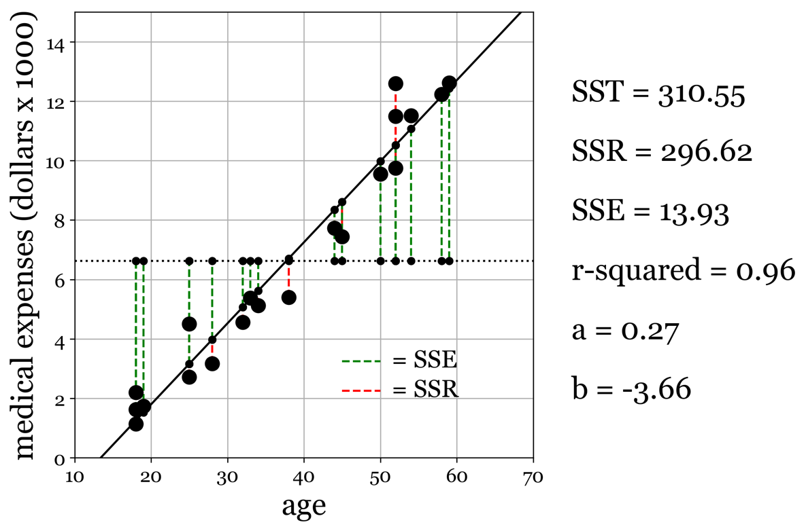
Figure 14.18 - Our regression model, derived using the above set of data and equations. The model found through this method aligns nicely with our expectations and our attempt to find the parameters manually through estimation.

